
L.J. Institute of Computer
Application
L.J. University

Master of Computer Application - Cybersecurity Specialization

MCA Cyber Security

3rd Semester

Subject Name: Digital Forensics and Incident Response

Subject Code: MCACS303

Submitted To: Mr. Jigar Gajjar

Submitted By: Chudasama Vishal
Roll Number: E02
CERTIFICATE

This is to certify that Mr. Chudasama Vishal Bhimashibhai with enrollment number 25004401110069 Semester 3rd has successfully completed his/her laboratory experiments in the Digital Forensics and Incident Response (MCACS303) from the department of MCA Cyber Security during the academic year 2025 - 2028

Date of Submission:

Staff in charge: Mr. Jigar Gajjar

TABLE OF CONTENT
Sr. No | Experiment Title | Page No | Date of Completion | Marks (Out of 10) | Sign
1 | Evidence Acquisition with FTK Imager | 4
2 | Autopsy: Deleted File Recovery & Activity Timeline | 9
3 | Windows Registry Forensic Analysis | 14
4 | Windows Event Log Analysis from own computer’s Event Viewer | 20
5 | Network Forensics with Wireshark | 24
6 | Emall Forensics | 31

Practical-1

AIM: “Evidence Acquisition with FTK Imager”

Procedure
Step 1: Install FTK Imager
FTK Imager was installed and launched to perform forensic evidence acquisition.
- Download FTK Imager (free) from the official Exterro website.
- Install and launch the application.
- Confirm the application opens successfully, showing the main FTK Imager window with File, View, Mode, Help menus.
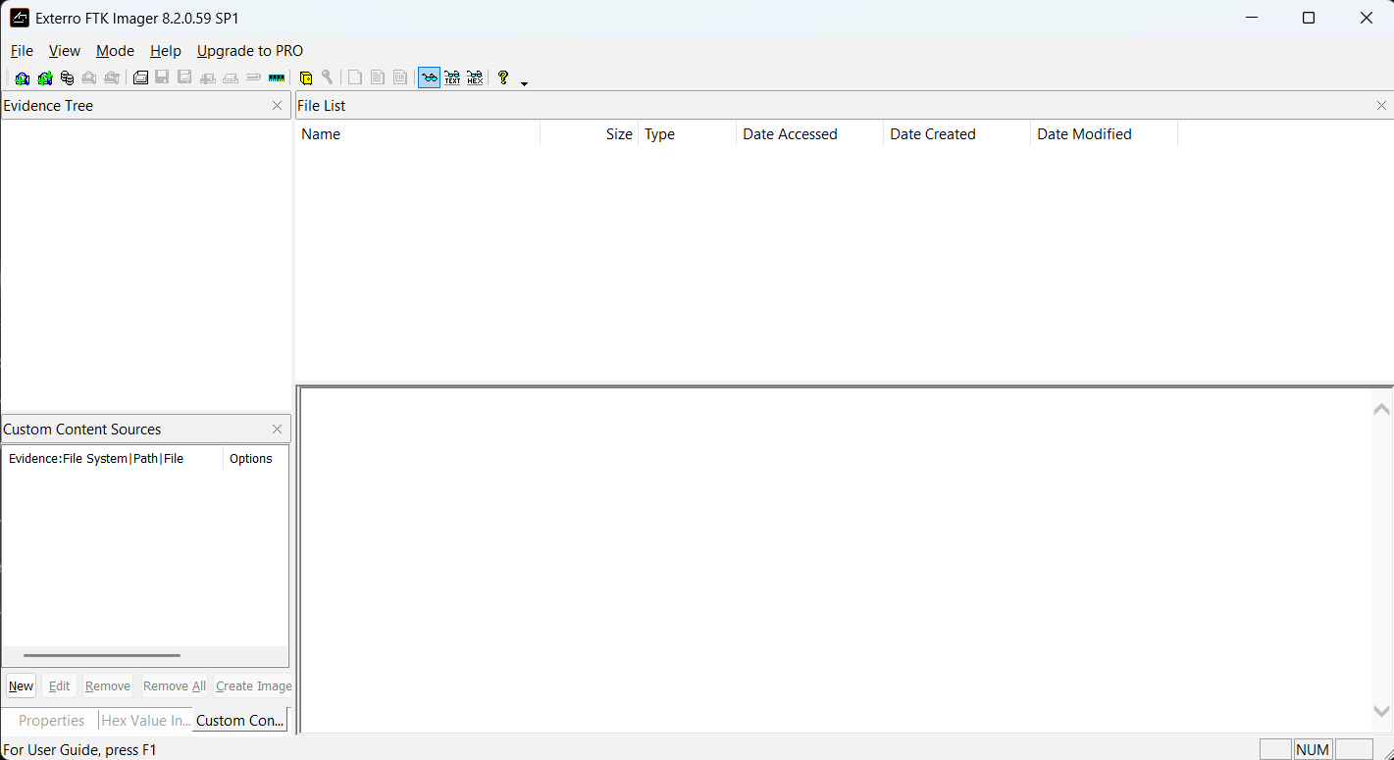
Figure 1: FTK Imager 8.2.0.59 SP1 launched and ready for forensic evidence acquisition.

Step 2: Capture Volatile Memory (RAM Capture)
An attempt was made to capture the system's volatile memory (RAM) using FTK Imager's built-in memory acquisition feature to preserve live system state data before it is lost on shutdown.
- FTK Imager was run with Administrator privileges.
- Windows Security → Device Security → Core Isolation → Memory Integrity was disabled and the laptop was restarted to remove potential driver-loading restrictions.
- In FTK Imager, File → Capture Memory was selected, with destination set to D:\memdump.mem.
- Capture Memory was clicked to begin acquisition.
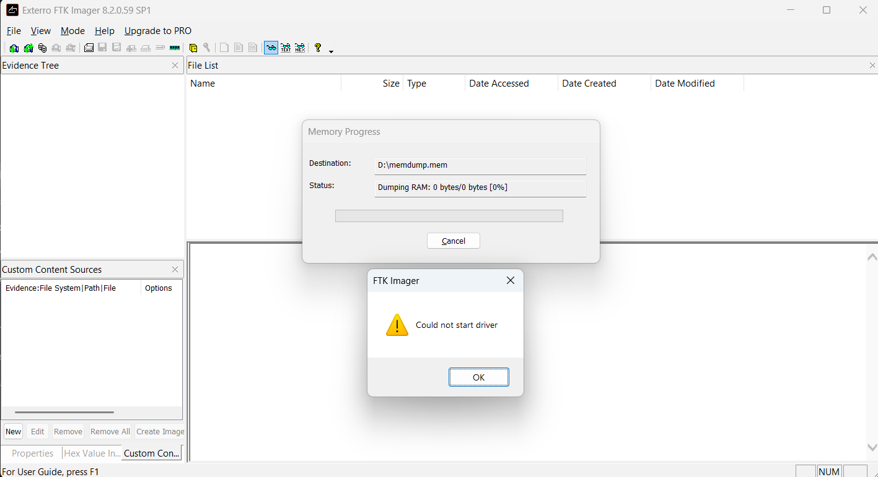
Figure 2: FTK Imager RAM capture attempt failing with "Could not start driver" error despite Administrator privileges and Memory Integrity disabled, indicating a kernel driver compatibility restriction on the host system.
POC Explanation
The "Could not start driver" error indicates that FTK Imager's kernel-level memory acquisition driver failed to load on this system, even after addressing the two most common causes — insufficient privileges (resolved via Administrator execution) and Core Isolation/Memory Integrity blocking (disabled prior to the attempt). This points to a deeper compatibility issue between FTK Imager 8.2.0.59's legacy driver and the current Windows build's Driver Signature Enforcement / kernel security policies, which increasingly restrict unsigned or outdated third-party drivers from accessing physical memory directly. This is a legitimate and commonly documented limitation in real-world forensic practice: volatile memory acquisition tools frequently fail on modern, hardened Windows systems, and analysts must note such failures accurately rather than assume the tool itself is broken. The failure was documented as evidence of a driver-level access restriction rather than a procedural error.

Step 3: Create Forensic Image of the USB Device
A forensic image of the USB pendrive (Physical Drive 1, 16GB HP pendrive) was created using FTK Imager in E01 format, capturing a complete bit-by-bit copy of the device for forensic analysis.

- In FTK Imager, File → Create Disk Image → selected Physical Drive → chose \\.\PHYSICALDRIVE1.
- Selected image type E01, filled in Evidence Item Information.
- Set destination to D:\Cyber\Image\pendrive_image, Image Fragment Size = 0 (single file), Compression = 6.
- Enabled "Verify images after they are created" and clicked Start.
- Waited for imaging and automatic verification to complete.

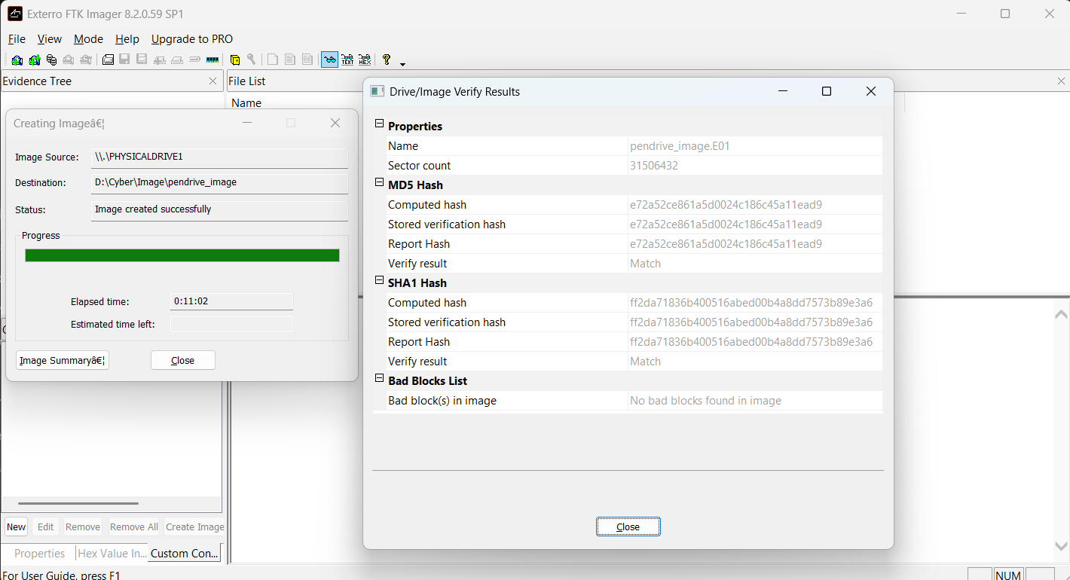
Figure 3: FTK Imager Drive/Image Verify Results confirming matched MD5 and SHA1 hash values with no bad blocks, validating successful forensic image creation of the USB pendrive.
The image was created successfully at D:\Cyber\Image\pendrive_image.E01 (Sector count: 31,506,432), with a total elapsed time of 0:11:02. The Drive/Image Verify Results confirmed:
- MD5: Computed hash = Stored verification hash = Report Hash = e72a52ce861a5d0024c186c45a11ead9 → Match
- SHA1: Computed hash = Stored verification hash = Report Hash = ff2da71836b400516abed00b4a8dd7573b89e3a6 → Match
- Bad Blocks: No bad blocks found in image.

POC Explanation
The successful match between the computed hash, stored verification hash, and report hash for both MD5 and SHA1 algorithms confirms that the forensic image is a byte-for-byte, unaltered copy of the original pendrive, with no data corruption introduced during the acquisition process. The absence of bad blocks further confirms clean, error-free sector-by-sector acquisition across the entire 16GB physical device. This dual-hash verification is critical in digital forensics, as it establishes the image's evidentiary integrity — proving in court or examination that the analyzed image faithfully represents the original evidence at the time of seizure.
Step 4: Verify Integrity via Hash Values (MD5/SHA1)
While hash verification occurred automatically during imaging (Step 3), the integrity of the acquired evidence was further confirmed by reviewing the auto-generated hash report file created by FTK Imager alongside the disk image.
- Navigate to the destination folder D:\Cyber\Image\ in File Explorer.
- Locate pendrive_image.E01.txt, generated automatically alongside the .E01 image file.
- Open the .txt report and review the Physical Drive Information and Computed Hashes sections.
- Compare the recorded MD5/SHA1 values against the Drive/Image Verify Results obtained in Step 3 to confirm they match exactly.
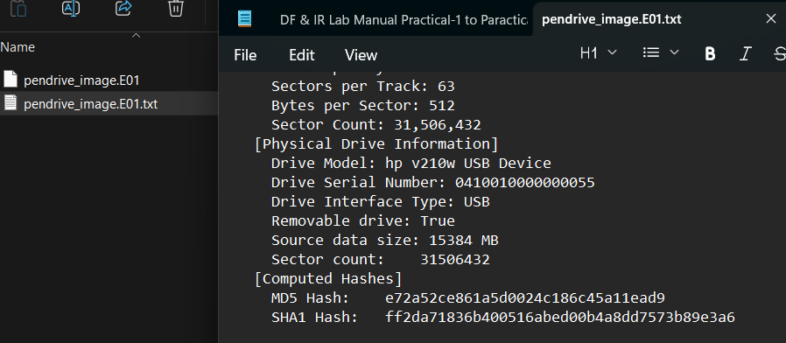
Figure 4: FTK Imager-generated hash report (pendrive_image.E01.txt) showing device information and computed MD5/SHA1 hash values confirming evidence integrity.
POC Explanation
The hash report independently documents the source device's identifying details (model, serial number, interface, size) alongside the computed MD5 and SHA1 checksums, providing a persistent, file-based record of the evidence's integrity beyond the live application session. The exact match between the report file's hashes and the in-application verification results (Step 3) confirms the acquired image is a forensically sound, unaltered copy of the original pendrive. This documented baseline is essential to chain-of-custody: any future re-hashing of the image (e.g., before court submission or peer review) can be compared against these recorded values to prove the evidence remained unmodified since acquisition.

Step 5: Complete Chain-of-Custody
Case Number | Practical1_EvidenceAcquisition
Evidence Number | USB-01
Description of Evidence | HP v210w 16GB USB Pendrive
Drive Serial Number | 0410010000000055
Interface Type | USB (Removable)
Source Data Size | 15,384 MB
Sector Count | 31,506,432
Date/Time of Acquisition | 23-08-2026 11:13 PM
Location of Acquisition | Ahmedabad, Gujarat, India
Acquisition Tool | FTK Imager 8.2.0.59 SP1
Image Filename | pendrive_image.E01
Image Format | E01 (EnCase), Compression Level 6
MD5 Hash | e72a52ce861a5d0024c186c45a11ead9
SHA1 Hash | ff2da71836b400516abed00b4a8dd7573b89e3a6
Verification Result | Match (No bad blocks found)
Storage Location of Image | D:\Cyber\Image\
Purpose / Reason for Acquisition | Practical-1: Evidence Acquisition Lab (DF & IR)
Observation
- FTK Imager was successfully installed and used for forensic evidence acquisition.
- RAM capture failed due to a "Could not start driver" error, even after running as Administrator and disabling Memory Integrity — indicating a kernel driver compatibility restriction on the host system.
- A forensic image of the 16GB HP USB pendrive (Physical Drive) was successfully created in E01 format with Best compression.
- Hash verification confirmed matching MD5 and SHA1 values between the computed hash, stored verification hash, and report hash, with no bad blocks detected.
- The auto-generated hash report file independently confirmed the same MD5/SHA1 values and device details (model, serial number, source size).
- A Chain-of-Custody form was completed, documenting evidence details, acquisition tool, hash values, and examiner information.
Conclusion
Evidence acquisition was performed using FTK Imager as part of this practical. While volatile memory (RAM) capture could not be completed due to a driver-level restriction on the host system, the forensic image of the USB pendrive was successfully created and verified, with matching MD5 and SHA1 hash values confirming the integrity of the acquired evidence. Completion of the Chain-of-Custody form further ensured proper documentation of evidence handling. These results demonstrate the standard forensic acquisition and integrity-verification workflow, including a realistic instance of a real-world tool limitation encountered and documented during the process.

Practical-2

AIM: “Autopsy: Deleted File Recovery & Activity Timeline”

Procedure
Step 1: Load the Pre-Seeded Forensic Image
For this practical, a pre-seeded forensic image (HASAN2.E01) was already provided within the TryHackMe lab environment, with an Autopsy case already created and the image loaded, ingest modules run, and analysis results populated.
- Open Autopsy on the provided TryHackMe lab machine.
- The pre-existing case was already loaded with the disk image HASAN2.E01 added as the data source.
- Reviewed the Data Sources table to confirm image details: Type, Size, Sector Size, Timezone, and Device ID.
- Selected the data source and reviewed the Results tab, confirming description: "OS Drive (Windows 10 Home)".
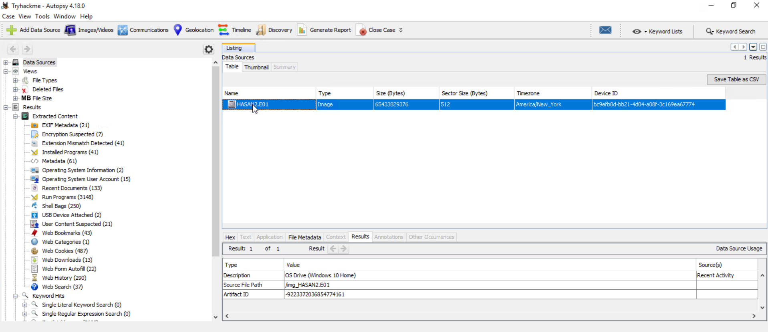
Figure 1: Pre-seeded forensic image HASAN2.E01 loaded in Autopsy, confirmed as a Windows 10 Home OS drive with populated Recent Activity artefact categories.
POC Explanation
The successful loading and description of HASAN2.E01 as a genuine Windows 10 Home OS drive image confirms this is a full operating system disk image, unlike smaller test images limited to isolated file recovery. The presence of populated categories such as Web History, Recent Documents, and USB Device Attached in the Extracted Content tree — visible immediately after ingest — confirms that this image contains real user activity artefacts, making it suitable for fulfilling all requirements of this practical: deleted file recovery, recent activity extraction, and timeline reconstruction.

Step 2: Analyze the File System and Recover Deleted Files
The Deleted Files category was analyzed in Autopsy to identify files removed from the file system but still recoverable from the disk image, with select files extracted to the Desktop for independent verification.
- In the left tree, expanded Deleted Files → File System (4717) → All (4717).
- Reviewed the Table view listing all recovered deleted files, along with their Modified, Change, and Access timestamps.
- Selected file and Right-clicked files → Extract File(s) → saved to Desktop.
- Verified extracted files appear on the Desktop as standalone,independently accessible files.
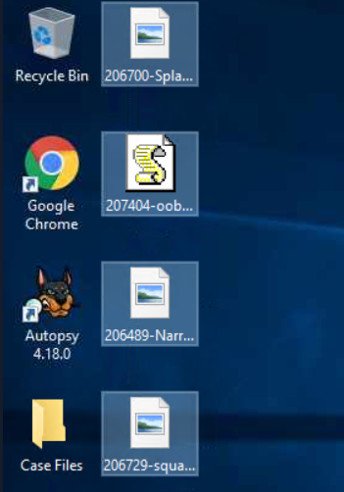
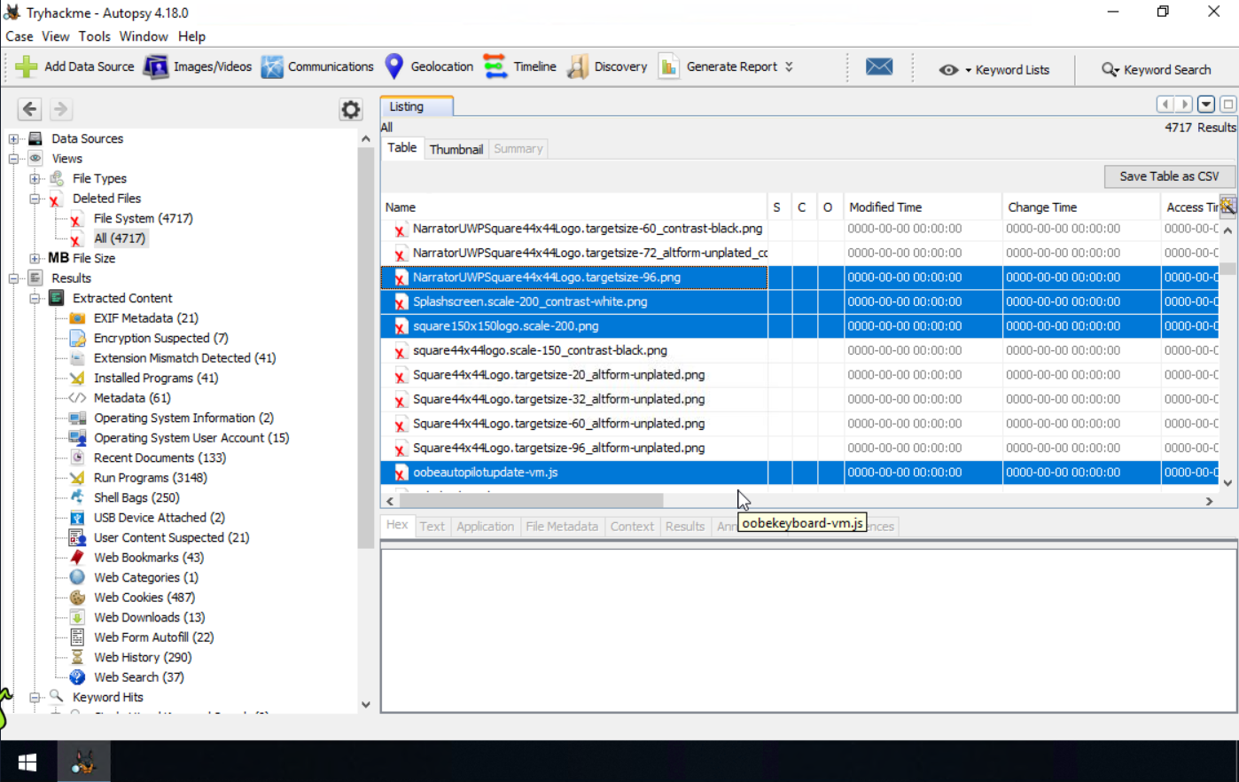
Figure 2: Deleted Files view in Autopsy (4,717 recovered entries) alongside the corresponding recovered files successfully extracted to the Desktop, confirming standalone accessibility outside Autopsy.
POC Explanation
The Deleted Files table shows all recovered entries with null (0000-00-00) timestamps, and the same selected files appear as standalone icons on the Desktop, confirming they were successfully extracted outside Autopsy.

Step 3: Extract Recent Activity Artifacts
The Extracted Content generated from the HASAN2.E01 forensic image was examined in Autopsy to identify recent user and system activity.
- Expand Results → Extracted Content in the Autopsy navigation tree.
- Review the populated recent-activity categories.
- The following artefact categories were identified:
  - Recent Documents (133)
  - USB Device Attached (2)
  - Web History (290)
  - Web Downloads (13)
  - Web Bookmarks (43)
  - Web Cookies (487)
  - Run Programs (3148)
  - Shell Bags (250)
- Select Web History and examine the recorded activity, including the URL, Date Accessed, Referrer URL, and Program Name.
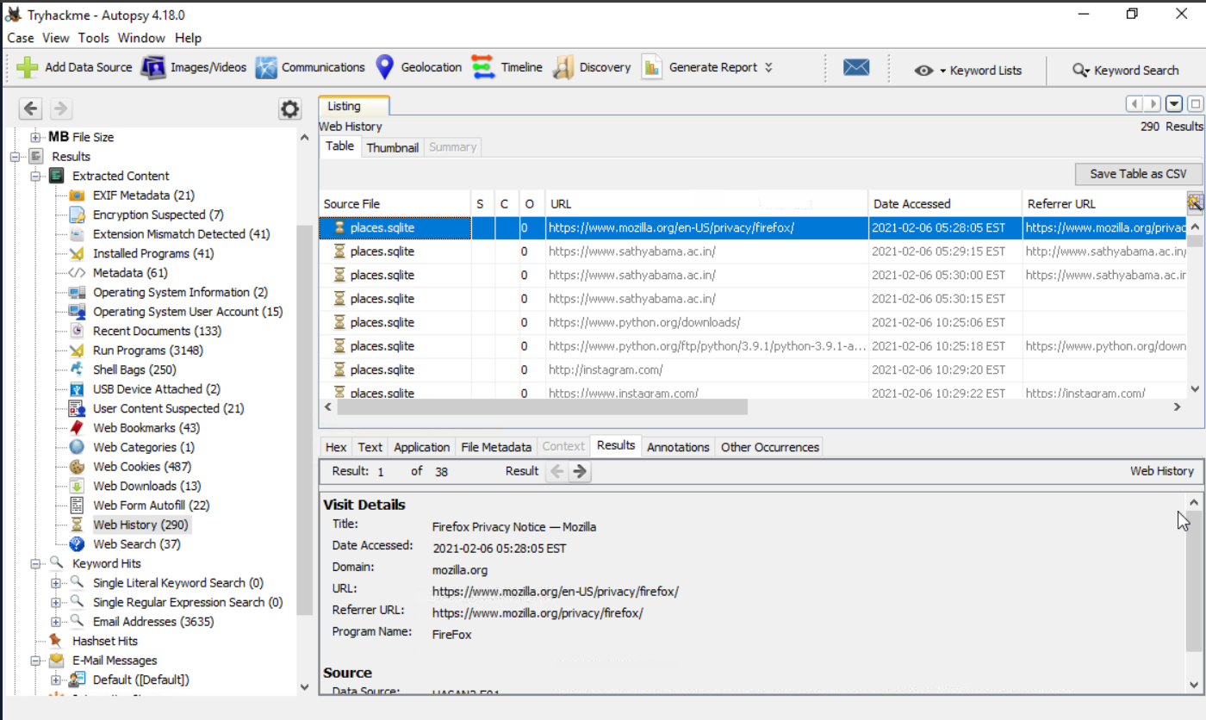
Figure 3: Web History artefacts recovered from places.sqlite showing browsed URLs, access timestamps, and visit details.
POC Explanation
The populated Extracted Content categories demonstrate that the forensic image contains recoverable user-activity artefacts. The Web History record provides a specific application, URL, and timestamp, which can be correlated with other artefacts to reconstruct user activity chronologically.

Step 4: Build and Analyze the Chronological Activity Timeline
The Timeline feature in Autopsy was used to correlate and analyze the timestamped forensic events extracted from the HASAN2.E01 image.
- Open Timeline from the Autopsy toolbar.
- Review the events in Counts view to observe their chronological distribution.
- Examine the displayed time range and event distribution.
- Review the timeline for the period containing the available user and system activity.

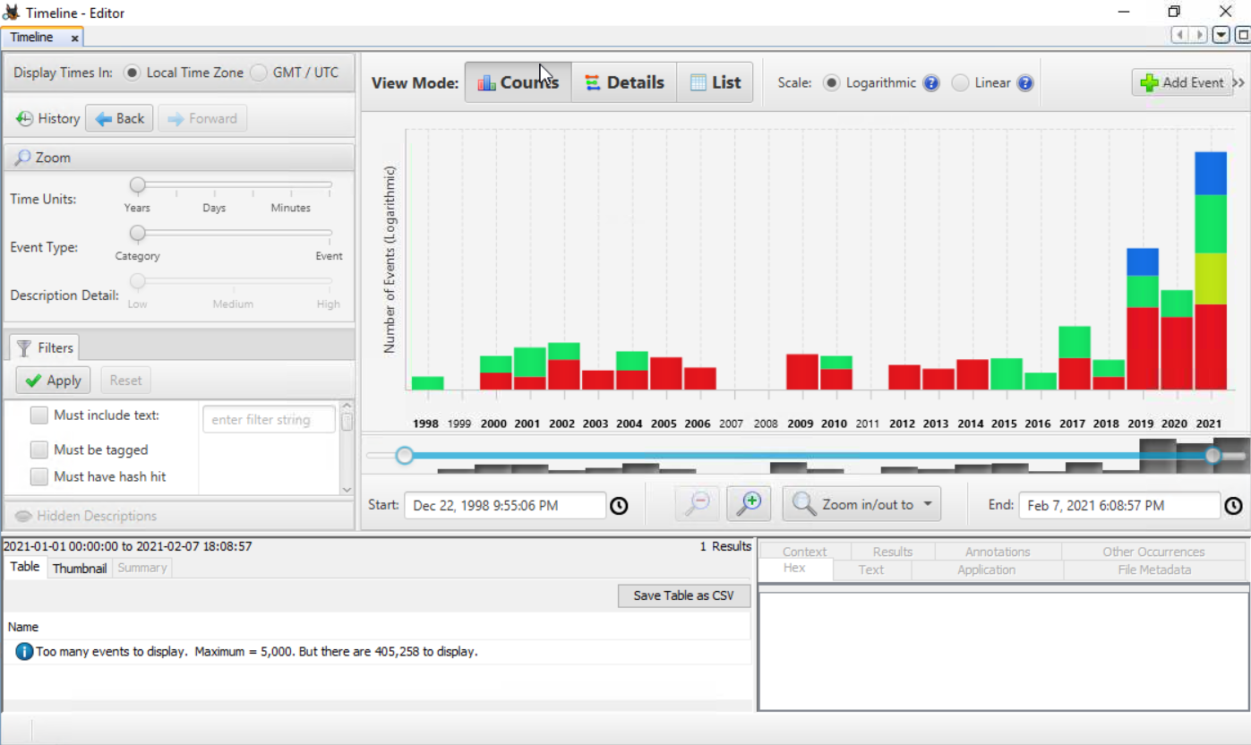
Figure 4: Autopsy Timeline displaying the chronological distribution of 405,258 forensic events from the HASAN2.E01 image.
POC Explanation
The Timeline contains a large number of timestamped events distributed from 1998 to 2021. For the selected analysis period. The displayed timeline extends to 7 February 2021, with concentrated activity visible during 2019–2021.
The Timeline consolidates timestamped forensic events into a chronological representation, allowing different activities to be correlated by date and time. The presence of 405,258 events demonstrates that the HASAN2.E01 image contains substantial temporal evidence suitable for reconstructing system and user activity.
Observation:
- 4,717 deleted files were recovered from the disk image under Deleted Files → File System, all showing null (0000-00-00) timestamps consistent with NTFS deleted directory entry recovery.
- Selected recovered files were successfully extracted to the Desktop, confirming standalone accessibility outside Autopsy.
- 290 Web History entries were recovered from places.sqlite, showing browsed URLs, access timestamps, and referrer chains via the FireFox browser.
- Autopsy's Timeline feature displayed event activity spanning December 1998 to February 2021, with the highest concentration of events in 2021.
- The 2021 timeline spike correlated directly with the Web History access timestamps recovered in Step 3, confirming consistent chronological evidence across artefacts.

Conclusion:
The forensic analysis of the pre-seeded disk image (HASAN2.E01) was successfully performed using Autopsy. Deleted file recovery yielded thousands of recoverable entries, several of which were independently verified through extraction. Recent activity artefacts, specifically Web History, provided detailed browsing evidence with exact timestamps. The Timeline feature further consolidated these findings into a chronological view, confirming that recovered artefacts aligned consistently in time. Together, these results demonstrate a complete deleted file recovery and activity timeline reconstruction workflow using Autopsy.

Practical-3

AIM: “Windows Registry Forensic Analysis”

Procedure
Step 1: Logs Load Windows Registry Hives
Registry Explorer 2026.5.0.0 was used to load the Windows Registry hive files required for forensic analysis. Since the Registry hive files under the Windows system directories are protected, Registry Explorer was started with Administrator privileges.
Action
- Right-click Registry Explorer and select Run as administrator.
- In Registry Explorer, select File → Load Hive.
- Load the following Registry hives from their respective locations:
SOFTWARE | C:\Windows\System32\config\SOFTWARE
SYSTEM | C:\Windows\System32\config\SYSTEM
NTUSER.DAT | C:\Users\vish\NTUSER.DAT
Amcache.hve | C:\Windows\AppCompat\Programs\Amcache.hve
- After loading, verify that each hive is displayed in Registry Explorer and its Registry tree is available for analysis.
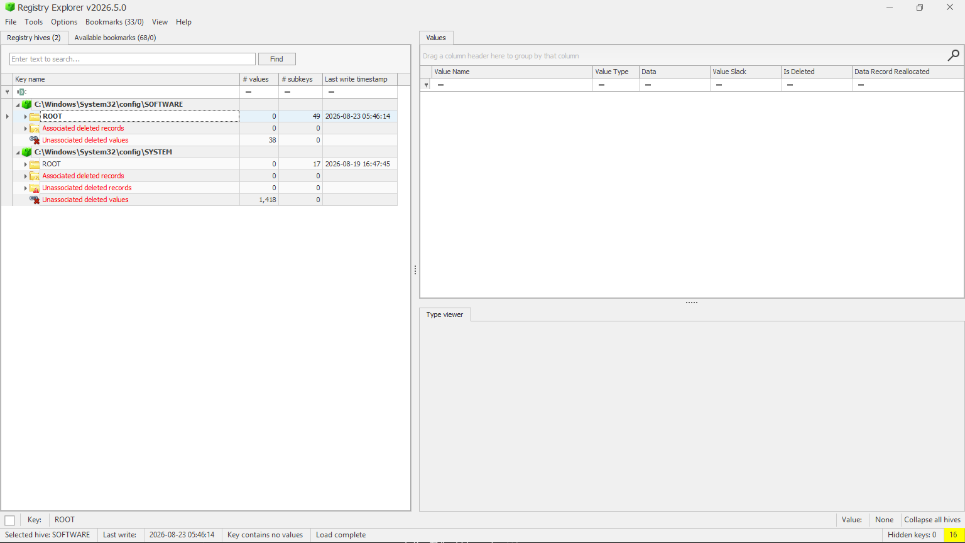
Figure 6: Registry Explorer running with administrator privileges and loaded Windows Registry hives for forensic analysis.
POC Explanation
The Registry hives contain different categories of forensic information. NTUSER.DAT provides user-specific artefacts, SYSTEM contains system and hardware-related information, and SOFTWARE contains system-wide application and configuration information. Amcache.hve is retained as supporting application evidence.

Step 2: Analyze Program Execution History – UserAssist (NTUSER.DAT)
The NTUSER.DAT hive is examined for Registry artefacts that record evidence of programs executed by the user. The UserAssist Registry keys are used for this analysis.
Action
In Registry Explorer, select the loaded NTUSER.DAT hive and navigate to:
NTUSER.DAT\Software\Microsoft\Windows\CurrentVersion\Explorer\UserAssist
Select the GUID subkey and open the Count subkey under it.
Under UserAssist, expand the available GUID subkeys and locate the Count subkey.
Select Count and examine the values displayed in the right pane.
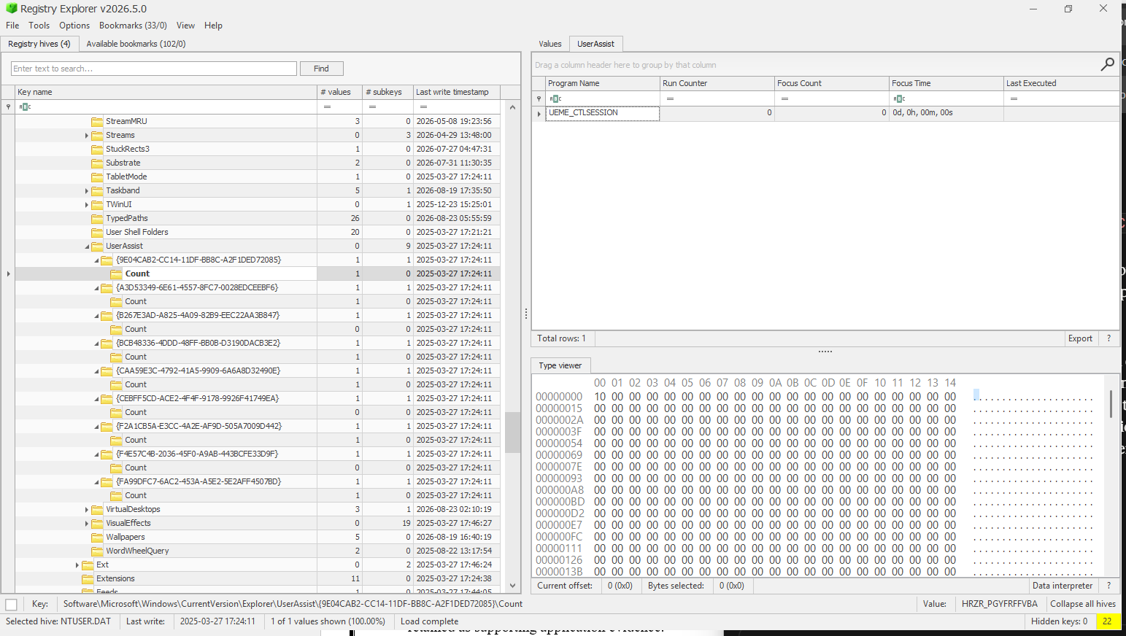
Figure 7: UserAssist registry key showing only the default UEME_CTLSESSION placeholder with no recoverable program execution entries.
POC Explanation
UEME_CTLSESSION is a default session-tracking value maintained by Windows Explorer and does not represent an executed application; it is present even when no user program-launch data has been recorded. Since none of the nine UserAssist GUID subkeys on this NTUSER.DAT hive contain a decoded program path with a non-zero Run Counter or Last Executed timestamp, it is concluded that the UserAssist artefact on this system does not hold recoverable program execution history

Step 3: Program Execution History – Shimcache/Amcache
Amcache.hve records metadata about executed applications, including file path, SHA-1 hash, and first execution timestamp, even for programs that have been deleted. This artefact is more reliable than UserAssist for establishing program execution history, as it is maintained at the system level and is harder to clear.
Action
- In Registry Explorer, select the loaded Amcache.hve hive from the Registry hives tab
- Navigate to the following path: Amcache.hve\Root\InventoryApplicationFile
- Identify a few relevant entries (e.g., non-system executables) showing file path and timestamp to use as evidence.
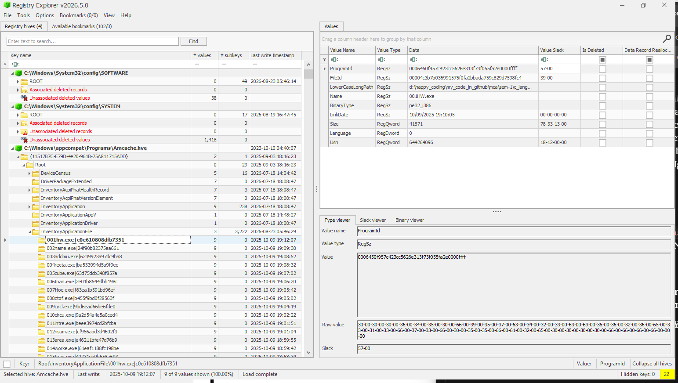
Figure 8: Amcache InventoryApplicationFile entry for a user-compiled executable (001HW.exe), confirming Amcache's ability to record execution metadata for self-created programs.
POC Explanation
This entry demonstrates that Amcache tracks execution artefacts for user-compiled/self-created executables, not only installed commercial applications. The file 001HW.exe, located in a personal C programming practice directory (d:\happy_coding\...\c_lang...), is recorded with its SHA-1 hash (FileId), exact file path, and LinkDate representing the binary's compilation timestamp. The presence of this entry confirms that Amcache captures execution metadata for any PE executable run on the system, regardless of its origin (installed software, portable tool, or self-compiled program), making it a comprehensive artefact for reconstructing a complete program execution history — including academic/development activity in this case.

Step 4: USB Device Connection Analysis (SYSTEM Hive)
The SYSTEM hive retains records of USB storage devices connected to the system, including vendor, product, serial number, and connection timestamps.
Action
- Select the SYSTEM hive in Registry Explorer.
- Navigate to: SYSTEM\CurrentControlSet\Enum\USBSTOR
- Expand the device subkey and its Serial Number subkey. Note the FriendlyName and Serial Number.
- For connection timestamps, check
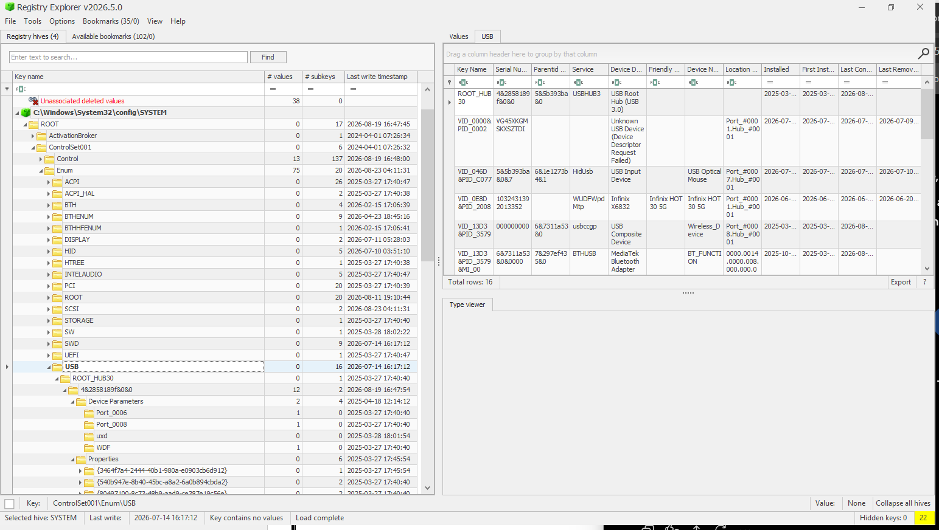
Figure 9: Enum\USB registry data showing an Infinix HOT 30 5G device connection with serial number and connection timeline.
POC Explanation
The Enum\USB key logs every USB device connected to the system, identified by Vendor ID (VID) and Product ID (PID), along with its unique serial number. The First Installed timestamp indicates when the device was first connected, while Last Connected and Last Removed establish a timeline of its most recent usage. This confirms that an Infinix HOT 30 5G smartphone was connected to the system via USB, providing device attribution and a connection timeline. key evidence in USB-based data exfiltration or device usage investigations.

Step 5: Persistence Mechanisms - Run/RunOnce Keys
Run and RunOnce keys store programs configured to execute automatically at user logon or system startup, commonly used for legitimate startup apps and, in malicious cases, for persistence.
Action
- Select the SOFTWARE hive (system-wide) and NTUSER.DAT hive (user-specific) in Registry Explorer.
- Navigate to:
SOFTWARE\Microsoft\Windows\CurrentVersion\Run
SOFTWARE\Microsoft\Windows\CurrentVersion\RunOnce
NTUSER.DAT\Software\Microsoft\Windows\CurrentVersion\Run
- Review the listed values — each entry's Name and Data show the program set to auto-start and its executable path.
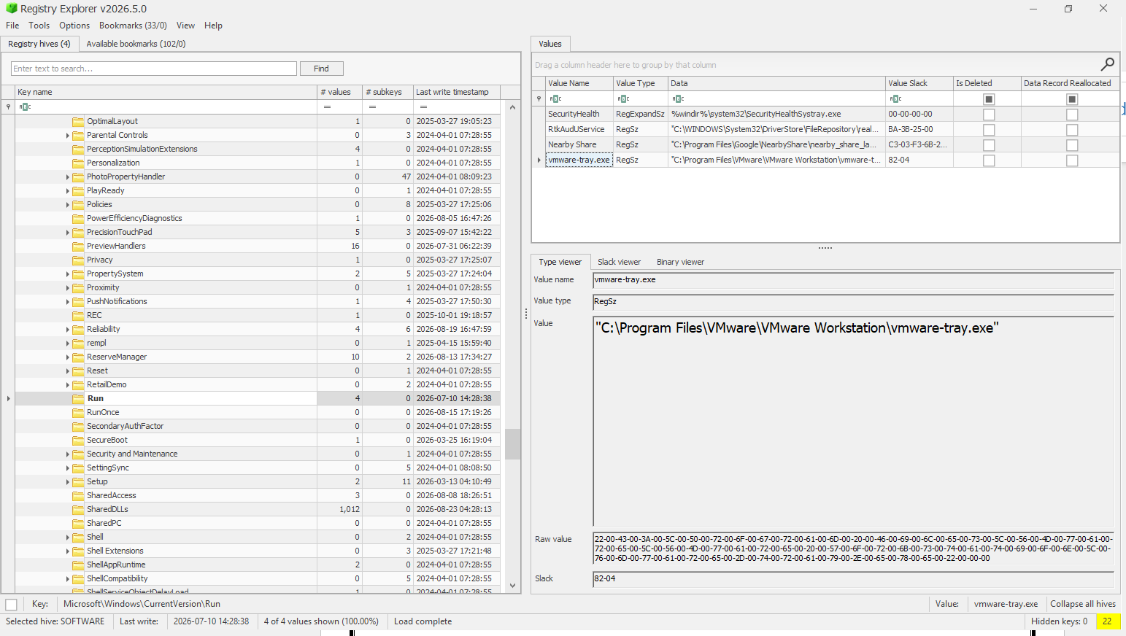
Figure 10: Run registry key showing configured auto-start applications for persistence analysis.
POC Explanation
Entries under the Run key execute automatically at every user logon, establishing persistence for the listed applications. The identified programs (Windows Security health monitor, Realtek audio service, Google Nearby Share, and VMware Workstation tray utility) correspond to legitimate installed software rather than suspicious or unknown binaries, indicating standard application persistence rather than malicious activity on this system. The empty RunOnce key confirms no single-execution startup entries are pending.
The NTUSER.DAT\Software\Microsoft\Windows\CurrentVersion\Run key (user-specific hive) was also examined and contains:
"C:\Program Files (x86)\Microsoft\Edge\Application\msedge.exe" --win-session-start

Step 6: Record and Document Forensic Artefacts
The extracted Registry artefacts are consolidated to document the findings obtained from the SYSTEM, SOFTWARE, and NTUSER.DAT hives.

The analysis produced evidence in the following three areas:
Forensic Area | Registry Hive | Artefact / Finding
Program/Application history | Amcache.hve | Application records under InventoryApplication
USB device connection | SYSTEM | USB device records, including Infinix HOT 30 5G
Persistence | SOFTWARE, NTUSER.DAT | Run/RunOnce startup entries
The persistence analysis identified legitimate startup entries including Windows Security health monitor, Realtek audio service, Google Nearby Share, VMware Workstation tray utility, and a user-level Microsoft Edge startup entry.

Observation
The Windows Registry hives were examined using Registry Explorer 2026.5.0.0. The analysis identified forensic artefacts related to application history, USB device connections, and persistence mechanisms.
- Program/Application History: Application records were identified in Amcache.hve under InventoryApplication.
- USB Device Connection: The SYSTEM hive contained USB device records, including an Infinix HOT 30 5G device with associated connection information.
- Persistence Mechanisms: SOFTWARE and NTUSER.DAT contained Run/RunOnce startup entries associated with installed applications.

Conclusion
Windows Registry forensic analysis successfully extracted relevant artefacts from the Registry hives. The findings provided evidence of application history, USB device usage, and configured startup mechanisms, demonstrating the usefulness of Windows Registry data in digital forensic investigations.

Practical-4

AIM: “Windows Event Log Analysis from own computer’s Event Viewer”

Procedure
Step 1: Open Windows Event Viewer and Access System Logs
Windows Event Viewer is used to examine event records generated by the Windows operating system. the System log is accessed to identify significant event IDs recorded on the local computer.
Action
- Press Win + R.
- Enter: eventvwr.msc
- Press Enter.
- In Event Viewer, navigate to: Windows Logs System
- Select System from the left panel.
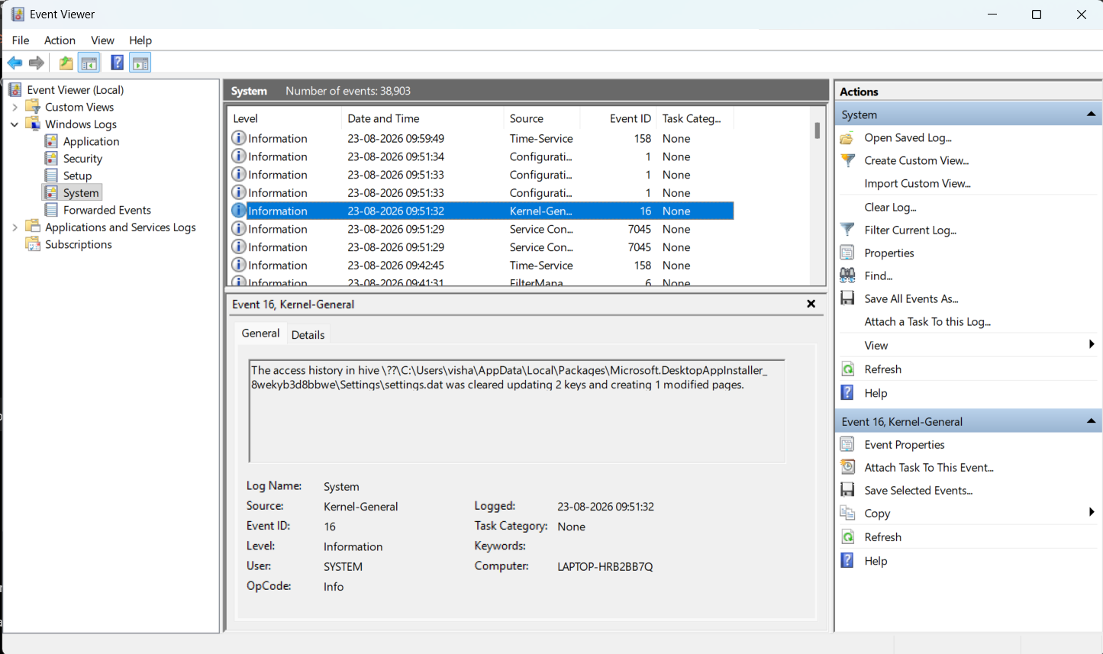
Figure 11: Windows Event Viewer displaying the System event log of the local computer.
Screenshot Explanation
The System event log contains records generated by Windows system components, services, drivers, startup/shutdown operations, and other system-level activities.
The System log provides the primary evidence source for identifying and analyzing important Windows event IDs generated by the local computer.
Step 2: Identify Critical and Important Event IDs
The System log is examined to identify events having Critical, Error, and Warning severity levels. These events are useful for forensic analysis because they can indicate system failures, unexpected shutdowns, service problems, driver issues, or other significant system activity.
Action
In the System log:
- Observe the Level column.
- Identify events marked: Critical, Information, Error, Warning
- Note their corresponding Event ID, Source, and Date and Time.
- Prefer event IDs that occur repeatedly or provide meaningful forensic information.
For easier identification, the log can be filtered using:
Right-click System → Filter Current Log...
Under Event level, select: Critical
Click OK.
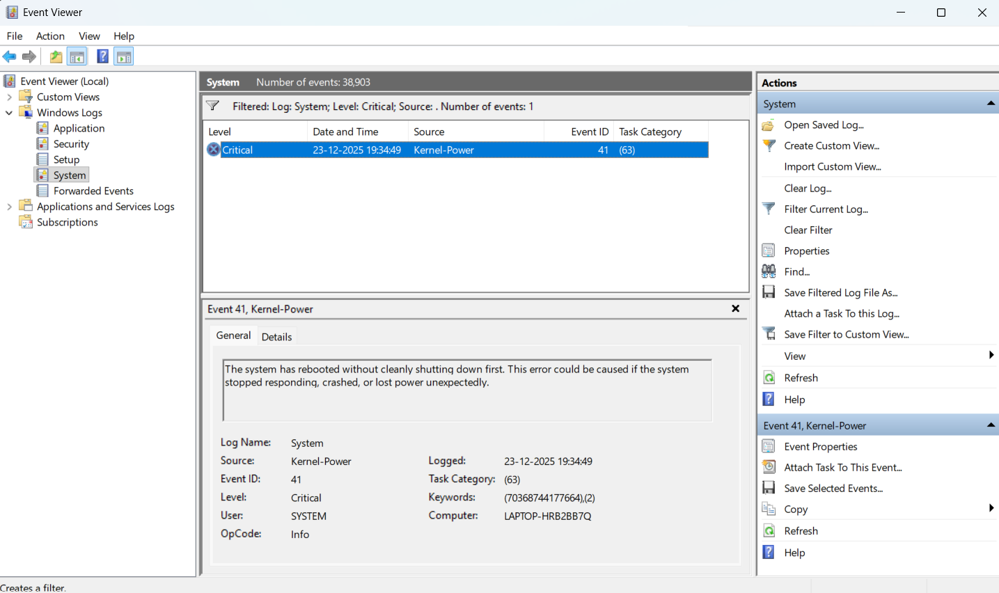
Figure 12: Critical Event ID 41 (Kernel-Power) identified from the Windows System event log.
POC Explanation
The screenshot confirms that Event ID 41 (Kernel-Power) is a Critical event recorded in the local System log. It is relevant for the practical because it provides evidence of an unexpected system restart or shutdown.

Step 3: Examine the Critical Event Details
Since the Event Viewer contains one Critical event (Event ID 41), the next required action is to examine its detailed event information for documentation.
Action
- Keep Event ID 41 – Kernel-Power selected.
- Open Event Properties by either:
  - Double-clicking the event, or
  - Selecting Event Properties from the right-side Actions panel.
- Keep the General tab open.
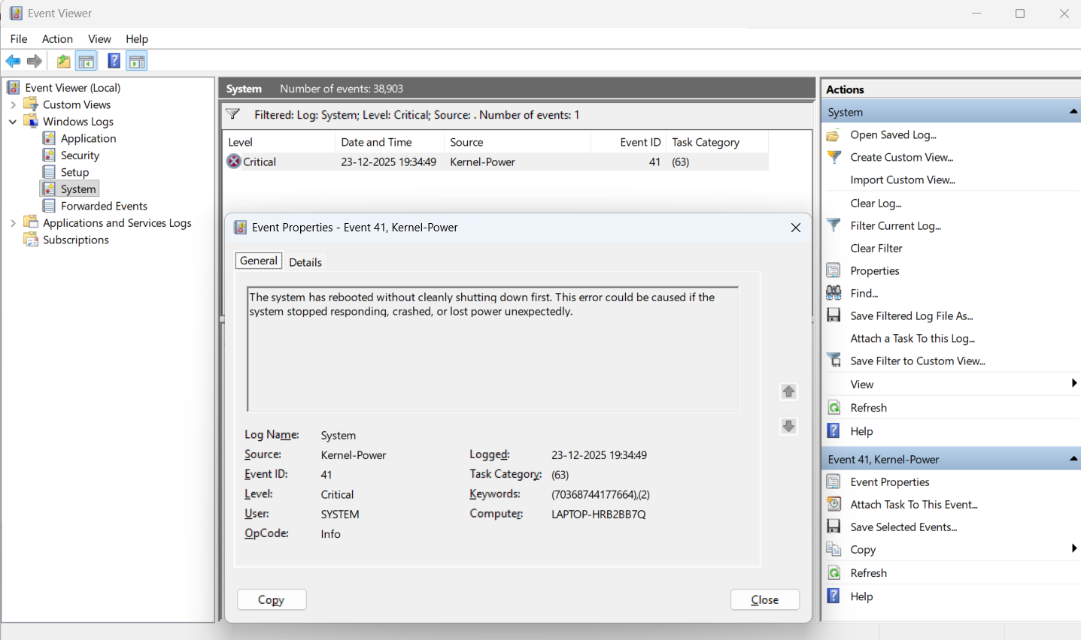
Figure 13: Event Properties showing details of Critical Event ID 41 generated by Kernel-Power.
POC Explanation
The Event Properties window records:
- Log Name: System
- Source: Kernel-Power
- Event ID: 41
- Level: Critical
- Logged: 23-12-2025 19:34:49
- Task Category: (63)
- User: SYSTEM
- Computer: LAPTOP-HRB2BB7Q
Event ID 41 provides evidence of an unexpected system restart without a clean shutdown. The event itself records the unexpected restart but does not establish the exact underlying cause.
Step 4: Record the Event ID and Prepare the Final Observation
The identified critical event is recorded as the final finding from the local Windows System log.
Identified Critical Event:
Event ID | Source | Level | Significance | Logged | User
41 | Kernel-Power | Critical | Indicates that the system rebooted without a clean shutdown. | 23-12-2025 19:34:49 | SYSTEM
The Event Viewer contained one Critical event after filtering the System log for the Critical level.

Observation:
The Windows System Event Log was filtered to identify Critical events. The analysis revealed one Critical event, Event ID 41 generated by Kernel-Power. The event was logged on 23-12-2025 at 19:34:49 and records that the system rebooted without a clean shutdown.

Conclusion:
The practical successfully identified and analyzed a Critical Windows Event ID from the local computer's Event Viewer. Event ID 41 (Kernel-Power) was documented along with its source, severity, timestamp, and significance.

Practical-5

AIM: “Network Forensics with Wireshark”

Requirements
- Wireshark
- malicious_pcap_final.pcap
- ftp-capture.pcap

Procedure
Step 1: Open and Analyze the Malicious PCAP File
Open Wireshark.
Go to: File → Open → malicious_pcap_final.pcap
Now look at the Protocol column. You should see different protocols such as:
FTP, HTTP, DNS, TCP, UDP
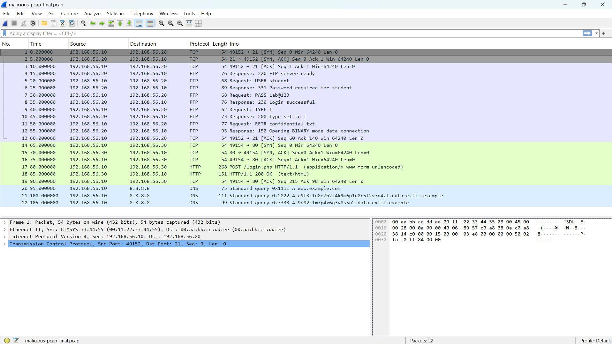
Figure 1: Overview of the malicious PCAP file analyzed using Wireshark
POC Explanation
A PCAP file contains captured network packets. Wireshark allows us to inspect these packets and identify suspicious communication, credentials, and attack activity.

Step 2: Analyze FTP Credentials from ftp-capture.pcap
Now, Open the second PCAP file
File → Open → ftp-capture.pcap
In the Wireshark Display Filter bar, enter: ftp
Press Enter.
Now inspect the Info column and the packet details.
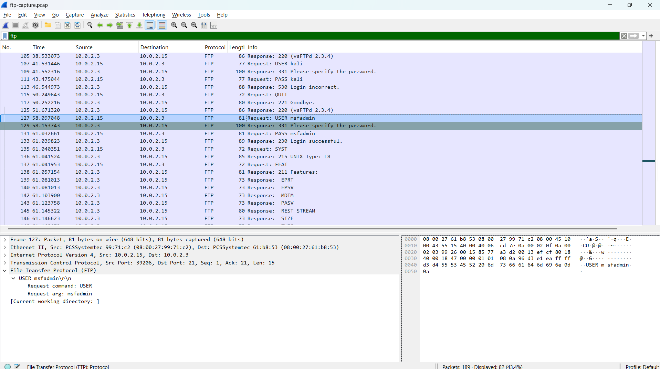
Figure 2: FTP credentials captured in plain text using Wireshark
POC Explanation
The FTP capture contains authentication attempts with credentials transmitted in plain text.
We can observe credentials such as:
Username: msfadmin
Password: msfadmin
The capture also contains an Anonymous FTP login and other unsuccessful login attempts.
FTP does not encrypt its authentication traffic. Therefore, when FTP packets are captured, the USER and PASS commands can be read directly in Wireshark.
This demonstrates that plain FTP can expose login credentials to anyone who is able to capture the network traffic.
Step 3: Analyze FTP File Access / Suspicious Activity
Now return to the first PCAP file:
File → Open → malicious_pcap_final.pcap
Apply the filter: ftp
Inspect the Info column and locate the file-transfer commands.
We can observe commands such as:
TYPE I
RETR confidential.txt
Select the packet containing:
RETR confidential.txt
Then right-click it and select:
Follow → TCP Stream
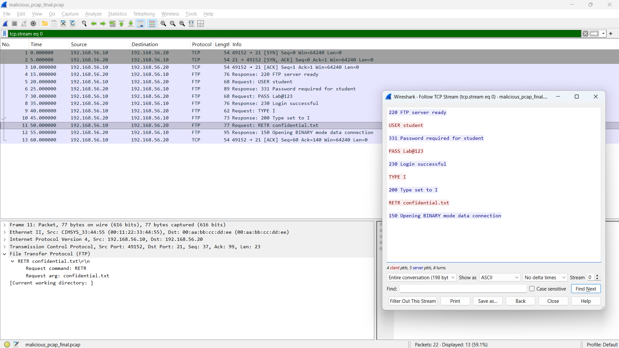
Figure 3: FTP file retrieval activity showing confidential.txt
POC Explanation
The FTP session shows that after authentication, the client requests the file:
RETR confidential.txt
The RETR command is used to retrieve a file from an FTP server. This shows that a file named confidential.txt was accessed during the FTP session.
Step 4: Detect DNS Anomaly / Possible DNS Tunneling & Beaconing
DNS queries were inspected to identify anomalous domain patterns and repeated periodic queries that may indicate DNS tunneling or beaconing-style data exfiltration.
In the Wireshark Display Filter bar, enter: dns
Press Enter.
Now inspect the DNS queries in the Info column.
Look for unusually long or random-looking domain/subdomain names.
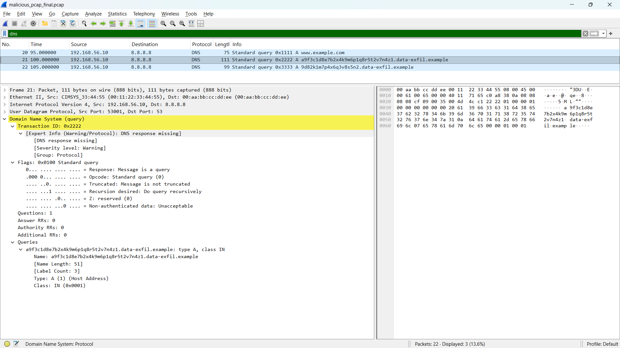
Figure 4: Detection of suspicious, regularly-spaced DNS queries with randomized subdomains indicating possible DNS tunneling and beaconing activity.
POC Explanation
The last two queries contain long, randomly generated subdomain labels under the domain data-exfil.example, which is characteristic of DNS tunneling, where data is encoded and exfiltrated through DNS query names.
The queries also occur in a short, regular sequence to the same resolver, resembling beaconing behavior repeated, low-interval outbound requests typical of an infected host periodically communicating with an external endpoint.
Unlike normal DNS resolution, which targets legitimate, human-readable domains, this repeated pattern of random-subdomain queries to a single suspicious parent domain indicates automated, non-user-initiated traffic consistent with a covert communication or exfiltration channel.
Step 5: Analyze HTTP Credentials
In the Wireshark Display Filter bar, enter: http
Press Enter.
Look for the HTTP request to: POST /login.php
Select the packet and expand Hypertext Transfer Protocol in the Packet Details section.
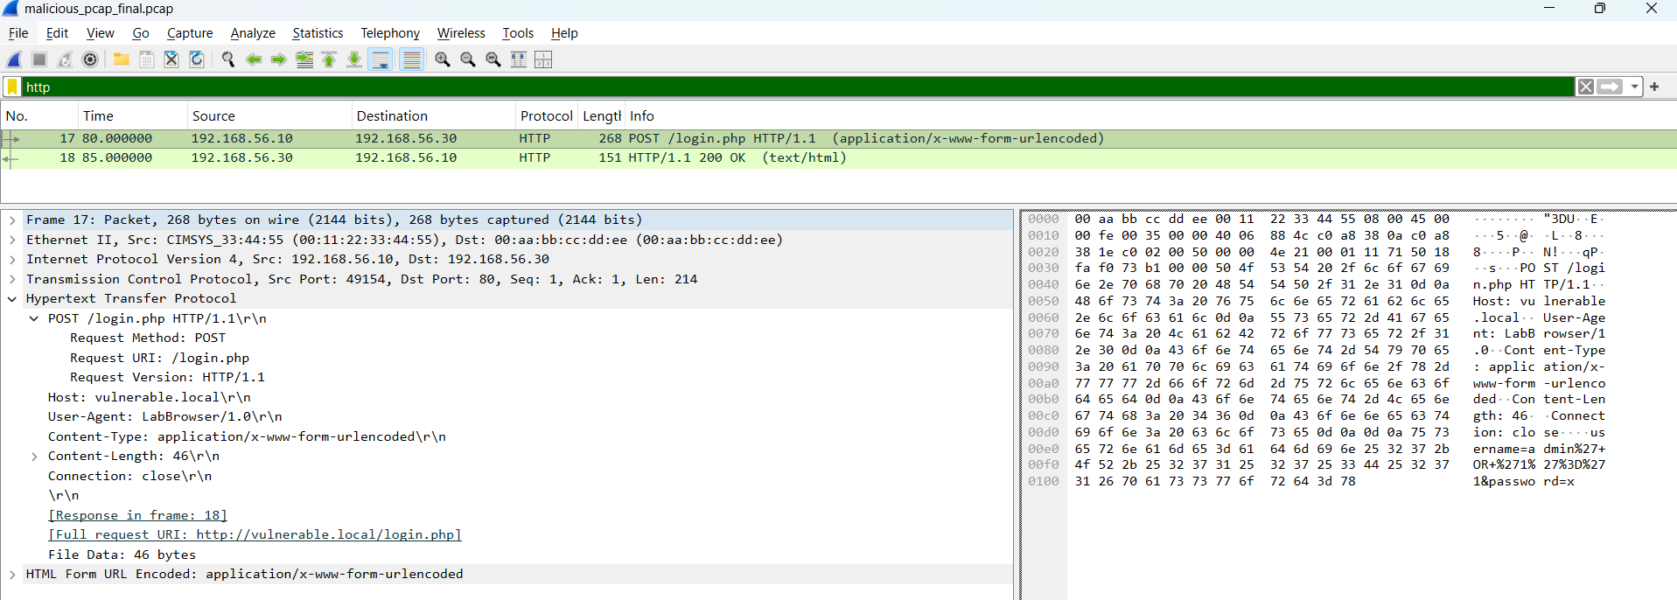
Figure 5: HTTP POST request exposing login credentials and parameters
POC Explanation
The HTTP POST request contains login parameters, including:
username= “admin”
password= “x”
HTTP does not encrypt its contents. Therefore, login information sent through an HTTP POST request can be viewed directly from a packet capture.
This demonstrates the risk of transmitting sensitive credentials over unencrypted HTTP.

Step 6: Identify SQL Injection Payload
Continue analyzing the HTTP POST packet from Step 5.
Look at the username parameter in the HTTP request. The value is URL-encoded as:
admin%27+OR+%271%27%3D%271
This can be decoded as:
admin' OR '1'='1
The suspicious part of the request is: ' OR '1'='1
We can also inspect the corresponding HTTP response and observe:
HTTP/1.1 200 OK
Login accepted
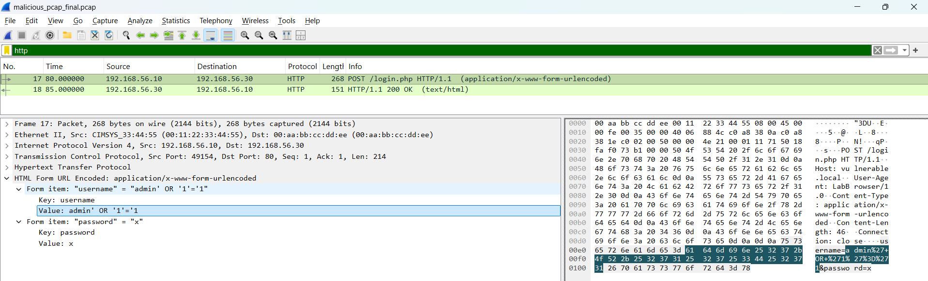
Figure 6: SQL injection payload detected in HTTP request
POC Explanation
The payload attempts to modify the application's SQL authentication condition. Since '1'='1' is always true, this type of input can be used to attempt an SQL Injection authentication bypass.
The successful response makes the activity suspicious and indicates that the vulnerable application accepted the crafted request.

Step 7: Reconstruct the Network Attack Timeline
Now we combine the observations from the previous steps and arrange them in chronological order using the Time, Source, Destination, Protocol, and Info columns in Wireshark.
POC
The observed attack sequence can be summarized as:
- FTP authentication — credentials are transmitted in plain text.
- FTP file access — RETR confidential.txt is used to request a file.
- HTTP login request — POST /login.php contains login parameters.
- SQL Injection — admin' OR '1'='1 is submitted as the username.
- Successful response — the server returns HTTP 200 OK and Login accepted.
- DNS anomaly — unusually long/random DNS queries are observed, indicating possible DNS tunneling or data exfiltration.
A network attack timeline helps us understand the relationship between individual packets and reconstruct the overall sequence of suspicious activities.
Observation:
- FTP credentials were exposed in plain text.
- FTP was used to request confidential.txt.
- HTTP transmitted login information without encryption.
- A SQL injection payload was detected in the HTTP request.
- Suspicious DNS queries containing long/random subdomains were identified, occurring at regular intervals consistent with beaconing behavior.
- The captured activities can be correlated using packet timestamps.

Conclusion:
The malicious PCAP was successfully analyzed using Wireshark. The analysis identified plain-text FTP credentials, suspicious FTP file access, exposed HTTP login data, SQL injection activity, and abnormal, beaconing-like DNS queries indicating possible tunneling. These findings were used to reconstruct the sequence of suspicious network activities.

Practical-6

AIM: “Emall Forensics”

Procedure
Step 1: Obtain the Email Headers (Own Inbox + Instructor Sample)
Two email headers were collected for comparison, a suspicious sample provided by the sir and a legitimate email retrieved from a personal inbox.
Action
- provided sample header (email-header-sample-1.txt), pre-supplied.
- Own inbox email, Gmail → open the email → 3-dot menu → Show original → raw header copied/exported as .eml.
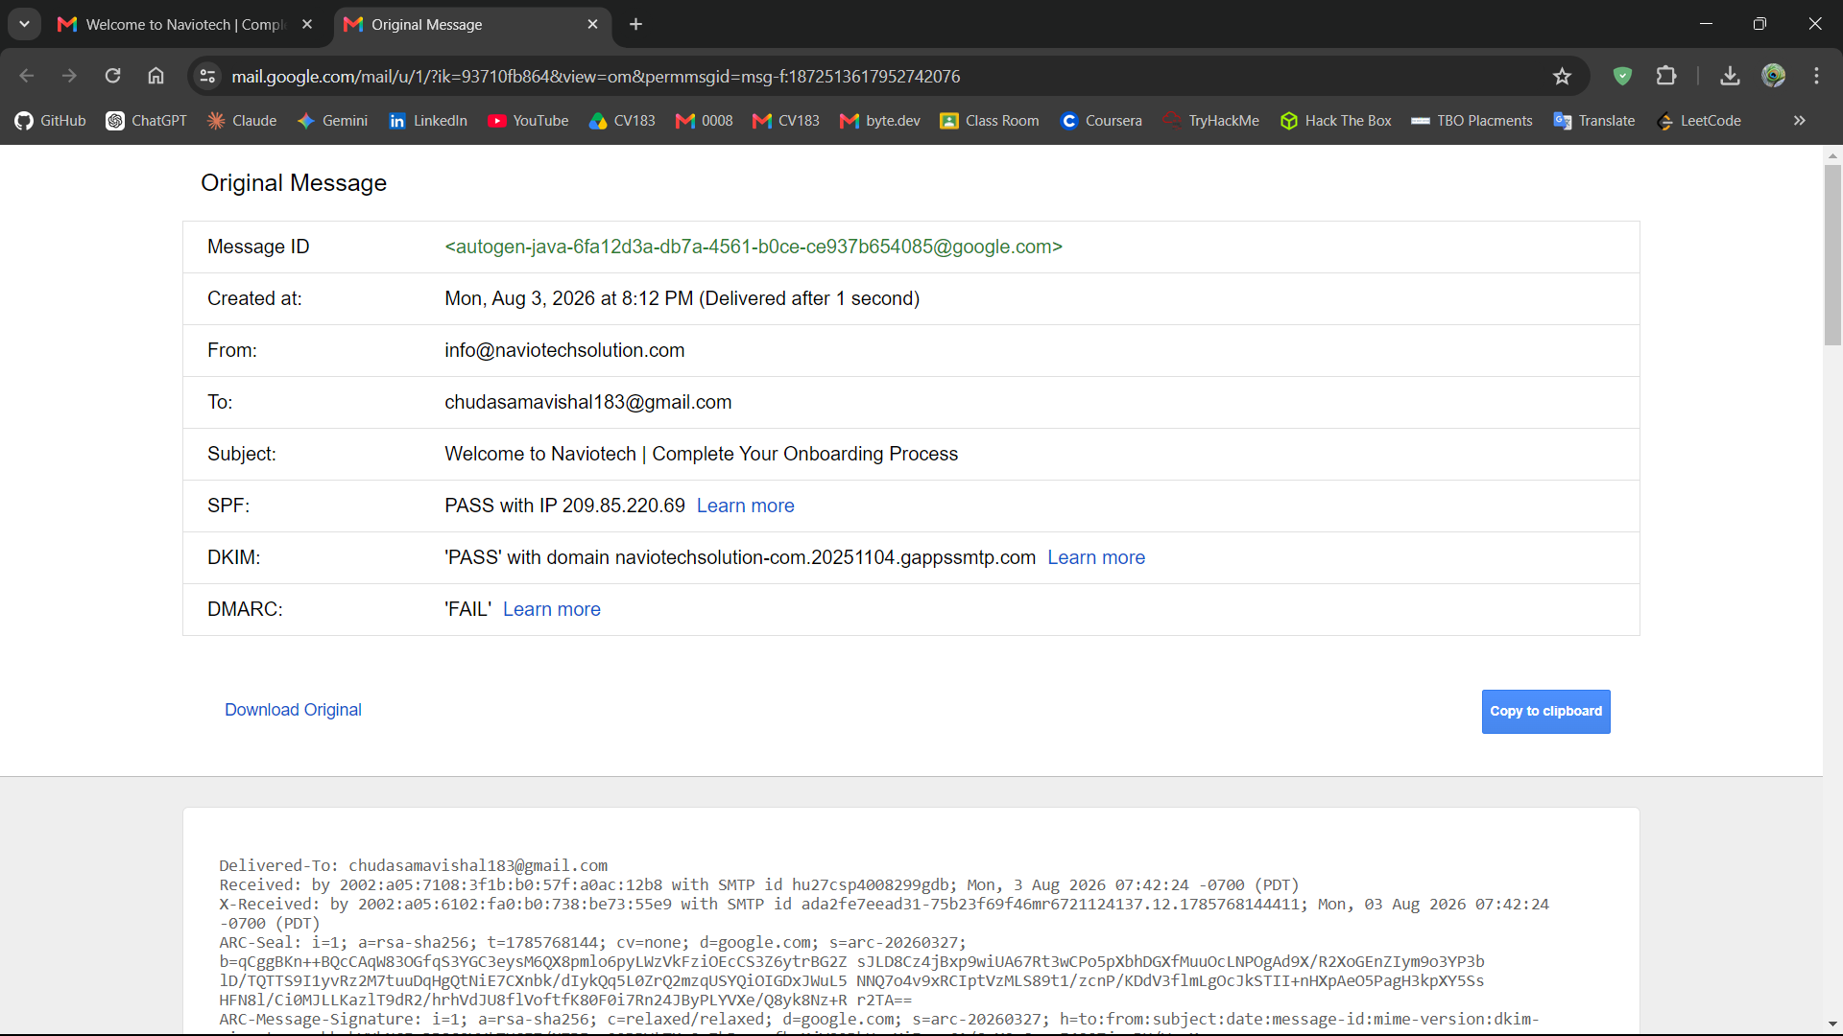
Figure 1: Raw email header obtained from Gmail using the "Show original" option for comparison analysis.

Step 2: Extract Raw Header Source & Parse Using Header Analyzer
The raw header source of both emails was extracted in full and passed through an online header analyzer tool to obtain a structured, hop-by-hop breakdown of the routing and authentication data.
Action
- Copy the complete raw header text of both emails.
- Open MxToolbox Email Header Analyzer: https://mxtoolbox.com/EmailHeaders.asp
- Paste the raw header into the tool and click Analyze Header — repeat separately for the provider-supplied sample and the own-inbox email.
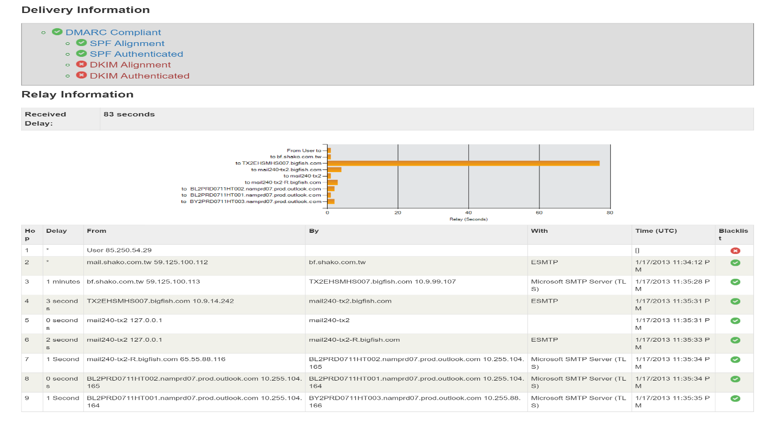
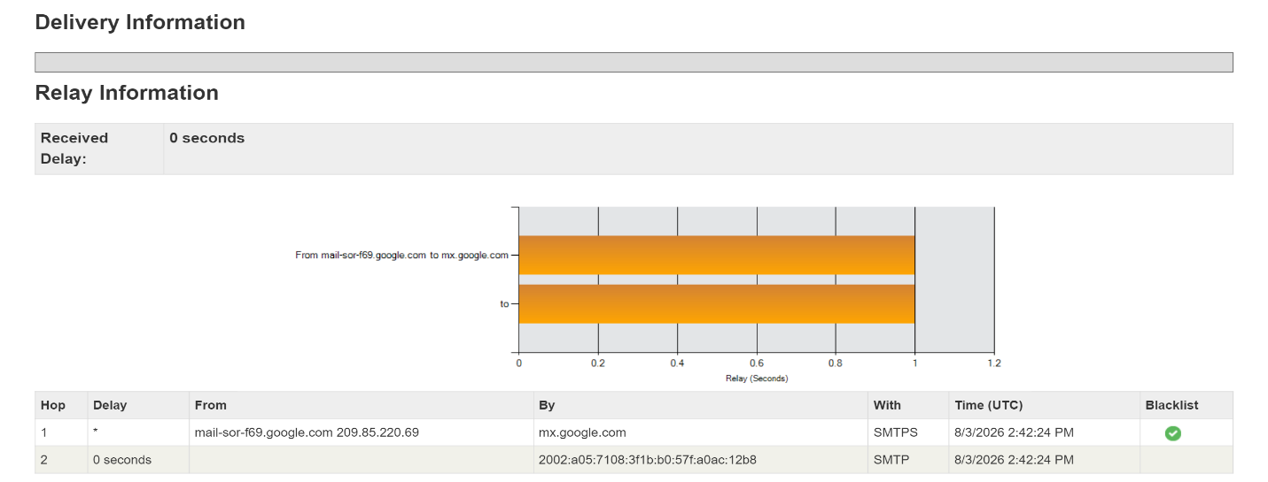
- Review the parsed output: Delivery Summary, Received chain, and Authentication results (SPF/DKIM/DMARC).
Figure 2b: MxToolbox Delivery Information for the provider-supplied sample header showing SPF authenticated but DKIM alignment and authentication failed.
Figure 2a: MxToolbox Authentication-Results for the own inbox email showing both SPF and DKIM passed.
POC Explanation

The own inbox email returns SPF: pass and DKIM: pass, confirming the sending server (209.85.220.69, Google infrastructure) was authorized to send on behalf of naviotechsolution.com and that the message content was not altered in transit. In contrast, the provider-supplied sample shows SPF: Authenticated but DKIM: Not Aligned / Not Authenticated, meaning no valid DKIM signature was present to verify sender identity and message integrity. The absence of DKIM in the sample, combined with its multi-hop relay through an unrelated domain (bf.shako.com.tw), is a strong indicator of a spoofed or unauthenticated sender, reinforcing that the sample email cannot be trusted as genuinely originating from aol.com.

Step 3: Analyze Basic Header Fields (From, To, Date, Message-ID, Return-Path)
The core identity fields of both headers were compared to check for sender/recipient consistency and possible spoofing indicators.
Action
Review the following fields directly from each raw header (or the MxToolbox "Headers Found" table):
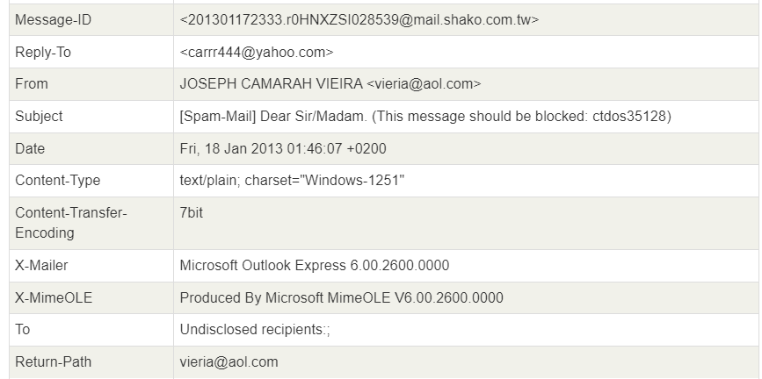
Figure 3: From, Reply-To, and Return-Path field mismatch in the provider-supplied header indicating sender spoofing.
Field | Own Inbox | Provider Sample
From | info@naviotechsolution.com | JOSEPH CAMARAH VIEIRA vieria@aol.com
Reply-To | (not present) | carrr444@yahoo.com
Return-Path | info@naviotechsolution.com | vieria@aol.com
Message-ID | ...@google.com | ...@mail.shako.com.tw
To | chudasamavishal183@gmail.com | Undisclosed recipients:;

POC Explanation
In the own-inbox email, From and Return-Path match exactly (naviotechsolution.com), and the Message-ID domain aligns with the sending infrastructure (Google), indicating a consistent, legitimate sender identity. In the provider sample, the Reply-To (carrr444@yahoo.com) differs from the From address (vieria@aol.com), and neither matches the Message-ID domain (mail.shako.com.tw), which is a classic spoofing red flag, replies are redirected to a different address than the one displayed as sender. The To field being "Undisclosed recipients" further indicates a mass/bulk spam distribution rather than a targeted, personal email.

Step 4: Trace the Received: Header Chain (Hop-by-Hop Path & IP Addresses)
The Received: header chain was traced hop-by-hop to identify the originating IP address and verify the routing path of both emails.
Review the Relay Information table in MxToolbox (Hop, From, By, With, Time columns) for both headers, reading bottom-to-top (the last Received: line = the originating hop, closest to the sender).

Own Inbox (Naviotech):
- Hop 1: mail-sor-f69.google.com (209.85.220.69) → mx.google.com — single hop, direct from Google's mail servers.

Provider Sample:
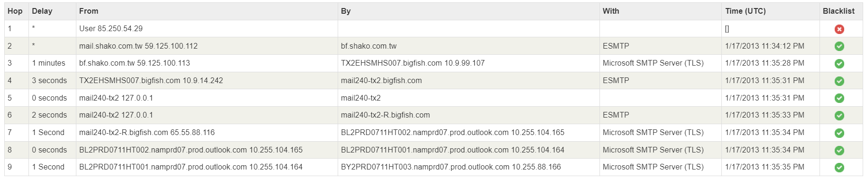
Figure 4: Nine-hop Received header chain for the provider-supplied sample showing IP 85.250.54.29 as the originating source with a falsely claimed hostname.
POC Explanation
The own-inbox email shows a single, direct hop from Google's authenticated mail server to the recipient's mail server, consistent with a legitimate, trusted sending infrastructure. The provider sample, in contrast, shows a 9-hop relay chain originating from IP 85.250.54.29, which falsely claims to be mail.shako.com.tw (per the X-Authentication-Warning header). The message is then relayed through an unrelated spam-filtering service (bigfish.com) before reaching Outlook servers. This long, inconsistent relay path, combined with the originating host falsely identifying itself, is a strong indicator of IP spoofing and an attempt to obscure the true origin of the email.

Step 5: Analyze Authentication Results (SPF / DKIM / DMARC Policy Records)
The actual SPF and DMARC DNS records were examined to determine the sending domain's configured policy, and compared against whether the message actually complied with that policy.
In the MxToolbox result page, review the "SPF and DKIM Information" section, which displays the raw DNS TXT records for the domain along with any DKIM signature errors.

Own Inbox (Naviotech):
- Authentication-Results: dkim=pass header.i=@naviotechsolution-com.20251104.gappssmtp.com; spf=pass ... smtp.mailfrom=info@naviotechsolution.com
Provider Sample (aol.com):
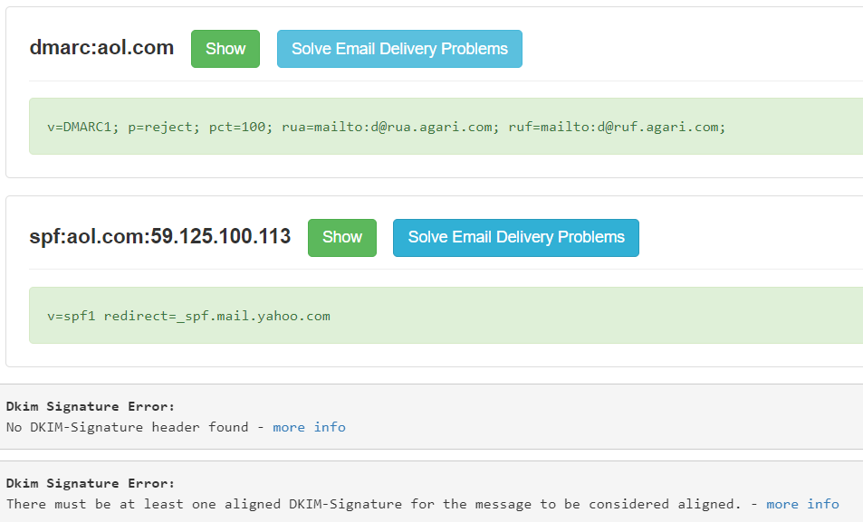
Figure 5: DMARC and SPF DNS records for aol.com alongside DKIM signature errors, showing policy non-compliance in the provider-supplied sample.
POC Explanation
The aol.com domain's own DMARC policy is explicitly set to p=reject, meaning aol.com instructs receiving mail servers to reject any message that fails SPF/DKIM alignment. However, this message has no DKIM signature at all and originates from an IP (59.125.100.113) not authorized under aol.com's SPF chain, meaning it should have been rejected under aol.com's own policy — yet it was still delivered, indicating the receiving server's spam filter (not strict DMARC enforcement) was relied upon to catch it, or that intermediate relays altered enforcement. In contrast, the own-inbox email fully passes both SPF and DKIM under its legitimate sending domain, confirming proper authentication end-to-end. This contrast highlights how a domain can have a strict security policy on paper while spoofed mail still slips through.

Step 6: Compare Both Headers & Identify Red Flags (Spoofing Indicators)
All findings from the previous steps were consolidated into a single comparison to clearly identify the red flags present in the provider-supplied sample.
Tabulate the key indicators from Steps 2–5 side-by-side for both headers to summarize the spoofing evidence.

Indicator | Own Inbox (Legitimate) | Provider Sample (Suspicious)
SPF | Pass | Neutral (not enforced)
DKIM | Pass | Missing (no signature)
DMARC | Compliant | Domain policy `p=reject` violated
From vs Return-Path | Match | Match (`vieria@aol.com`)
From vs Reply-To | N/A (no Reply-To) | Mismatch (`vieria@aol.com` vs `carrr444@yahoo.com`)
Relay Hops | 1 (direct) | 9 (multi-hop, unrelated relay)
Originating Host | Verified Google server | Falsely claimed hostname (`X-Authentication-Warning`)
Spam Score | N/A | 73 (flagged: "This message appears to be spam")
Recipient Field | Specific address | "Undisclosed recipients" (bulk mail)

Conclusion
The email header forensic analysis was successfully performed by comparing a legitimate email header from a personal inbox with a provider-supplied suspicious sample using Wireshark-independent header analysis and the MxToolbox Email Header Analyzer. The analysis revealed clear authentication failures (missing DKIM, unenforced SPF), a sender identity mismatch between the From and Reply-To fields, an abnormally long relay chain with a falsely claimed originating hostname, and a high spam score in the suspicious sample — all of which were absent in the legitimate email. These red flags collectively confirm that email header analysis is an effective forensic technique for detecting spoofed or fraudulent email communications.

